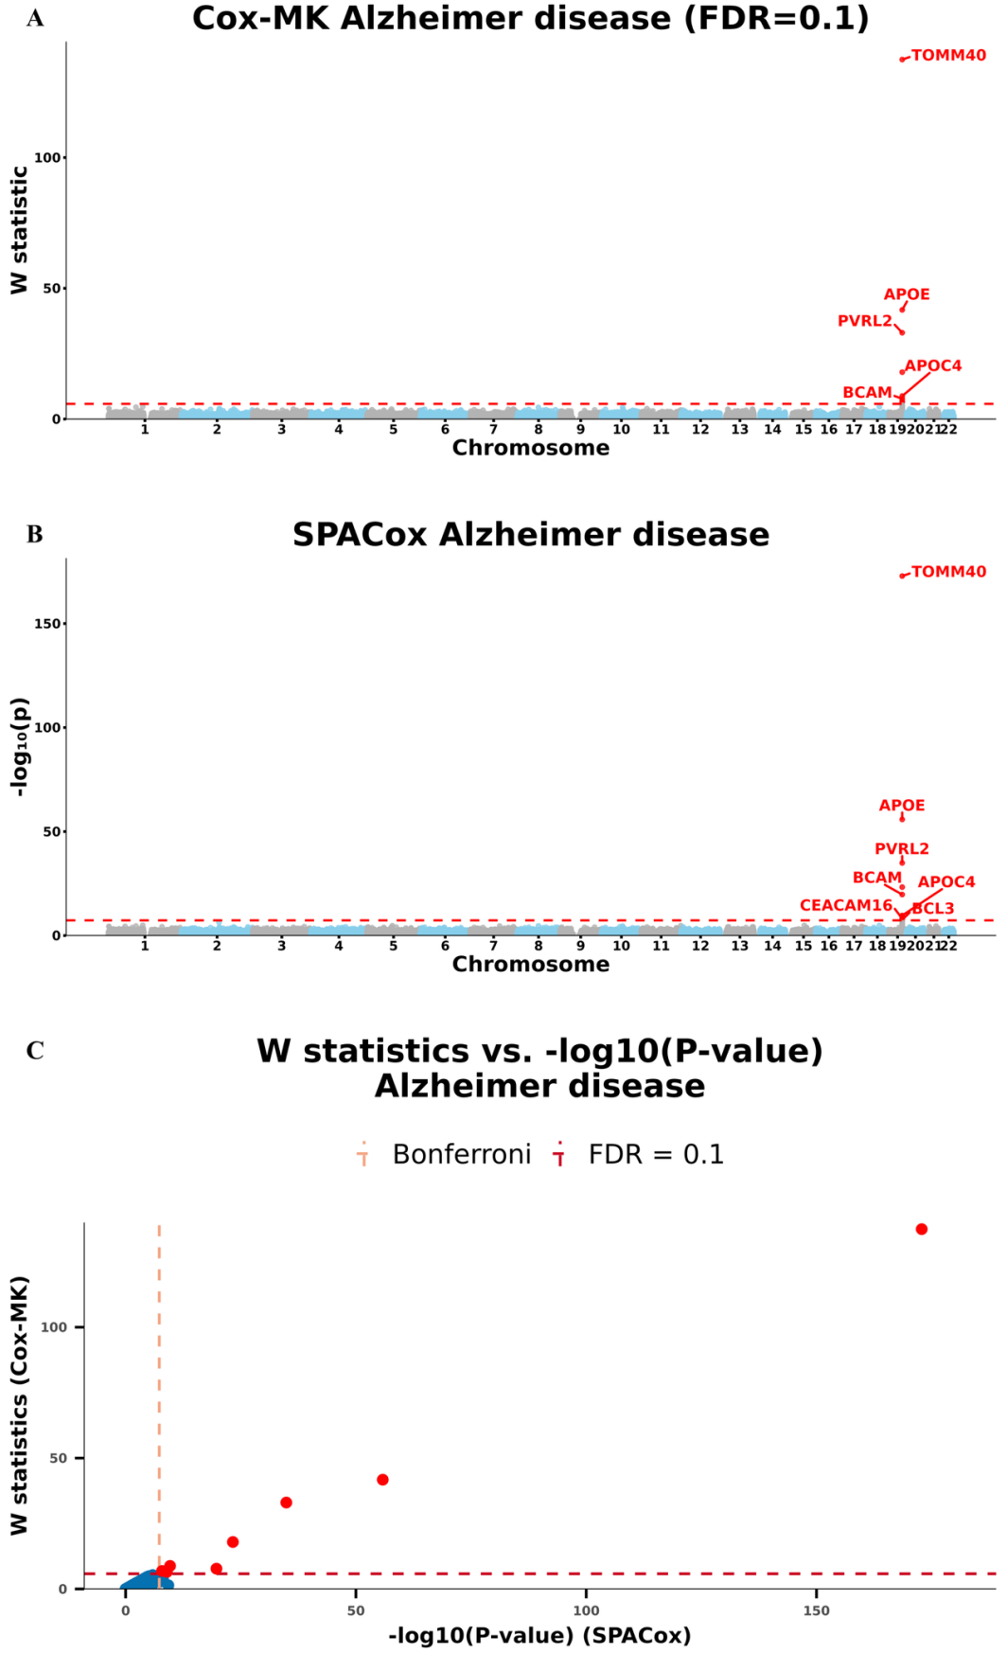
Figure S1. Manhattan plots for GWAS of alzheimer disease in the UK Biobank data with White British ancestry
(A and B) GWAS results using (A) Cox-MK and (B) SPACox are shown for alzheimer disease.
(C) Scatter plot of W knockoff statistics (Cox-MK) vs. −log10(p value) (SPACox) for alzheimer disease.
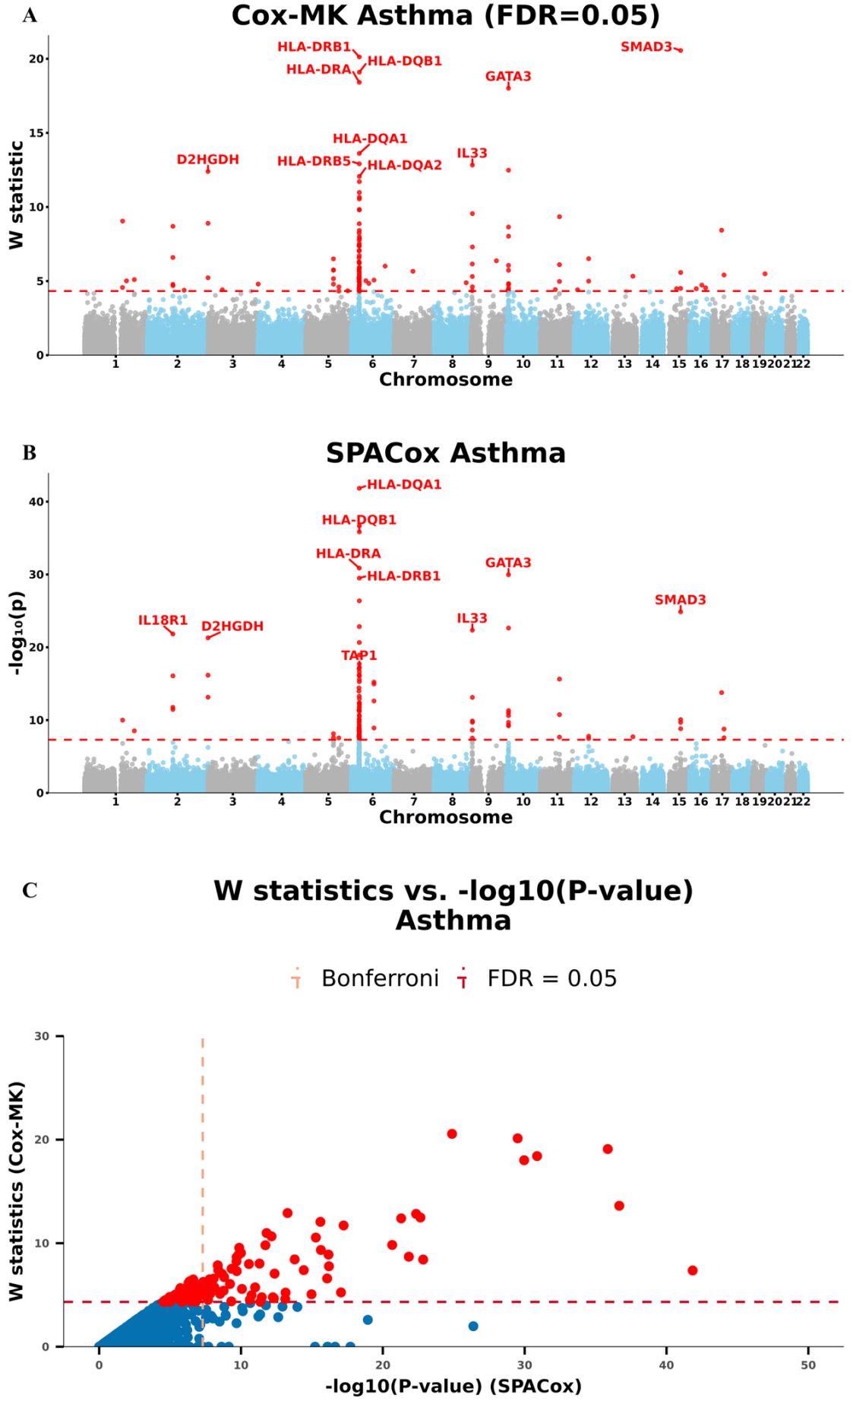
Figure S2. Manhattan plots for GWAS of asthma in the UK Biobank data with White British ancestry
(A and B) GWAS results using (A) Cox-MK and (B) SPACox are shown for asthma.
- Scatter plot of W knockoff statistics (Cox-MK) vs. −log10(p value) (SPACox) for asthma.
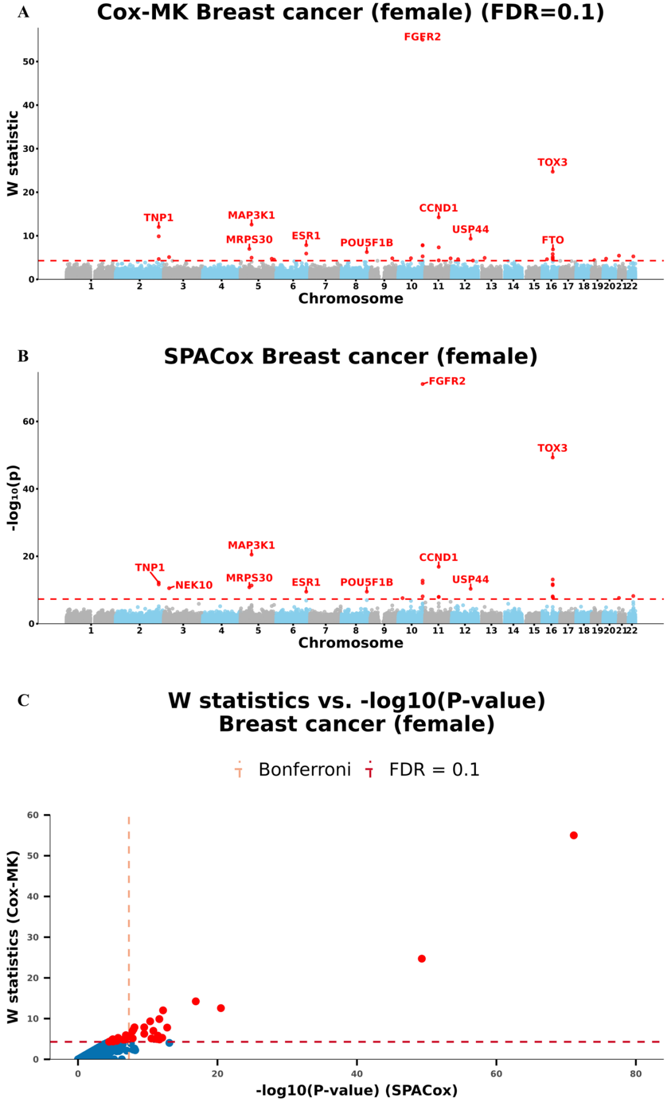
Figure S3. Manhattan plots for GWAS of breast Cancer (female) in the UK Biobank data with White British ancestry
(A and B) GWAS results using (A) Cox-MK and (B) SPACox are shown for breast cancer (female).
- Scatter plot of W knockoff statistics (Cox-MK) vs. −log10(p value) (SPACox) for breast cancer (female).
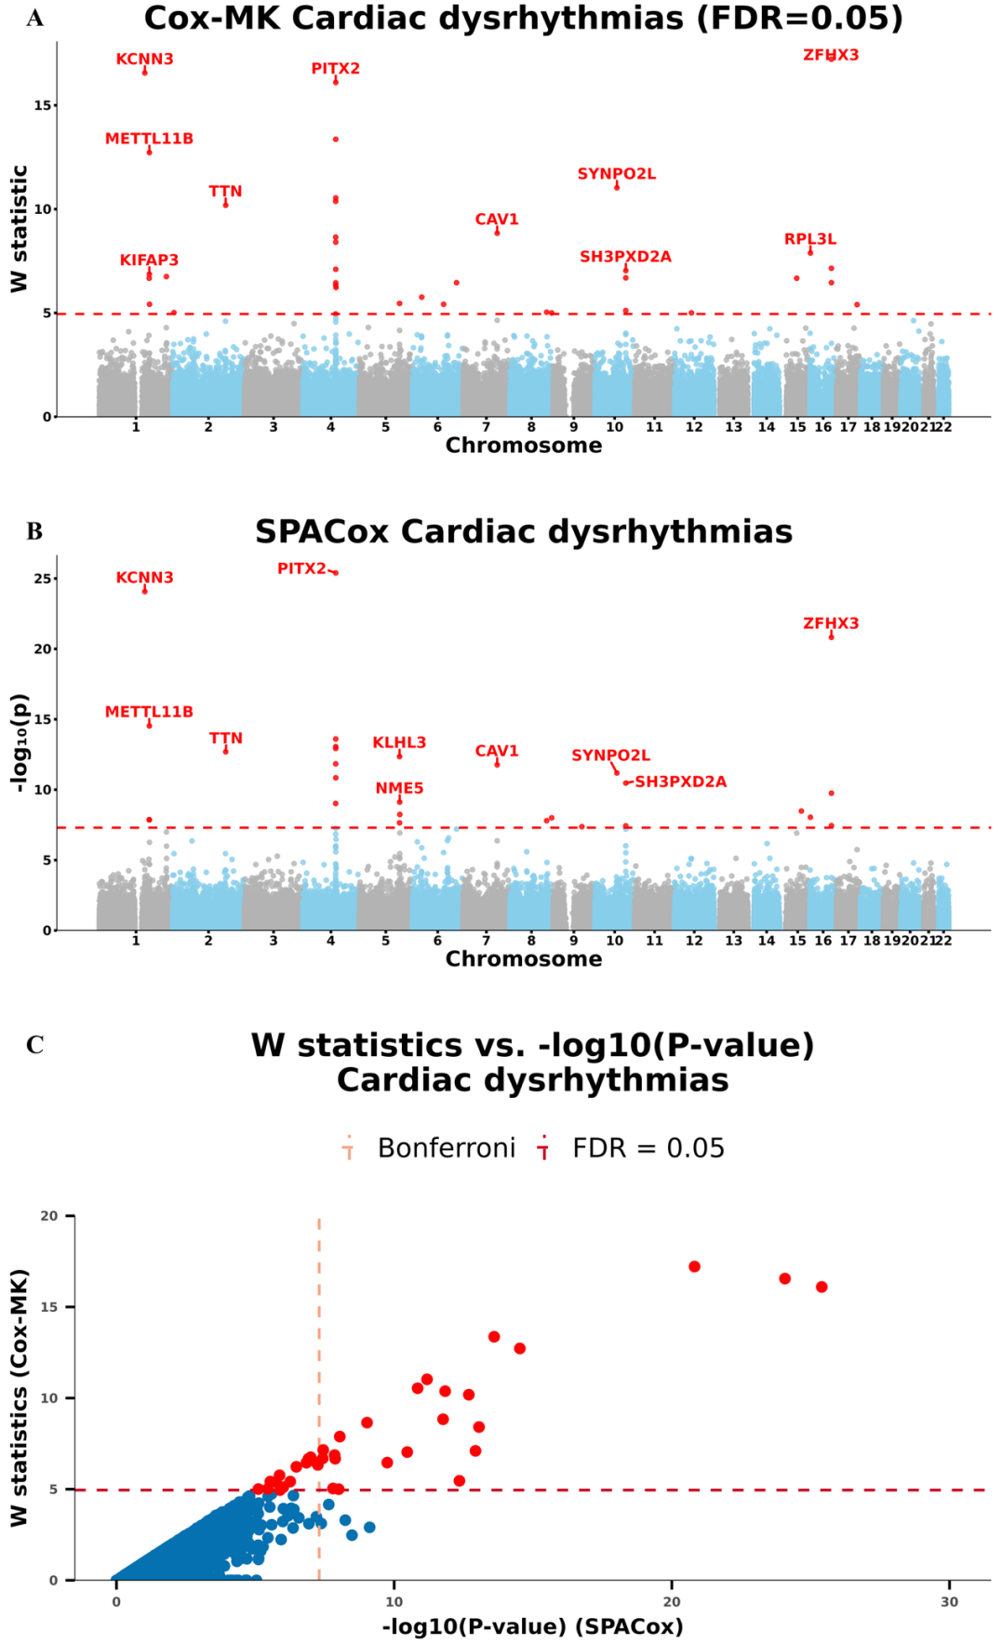
Figure S4. Manhattan plots for GWAS of cardiac dysrhythmias in the UK Biobank data with White British ancestry
(A and B) GWAS results using (A) Cox-MK and (B) SPACox are shown for cardiac dysrhythmias.
- Scatter plot of W knockoff statistics (Cox-MK) vs. −log10(p value) (SPACox) for cardiac dysrhythmias.
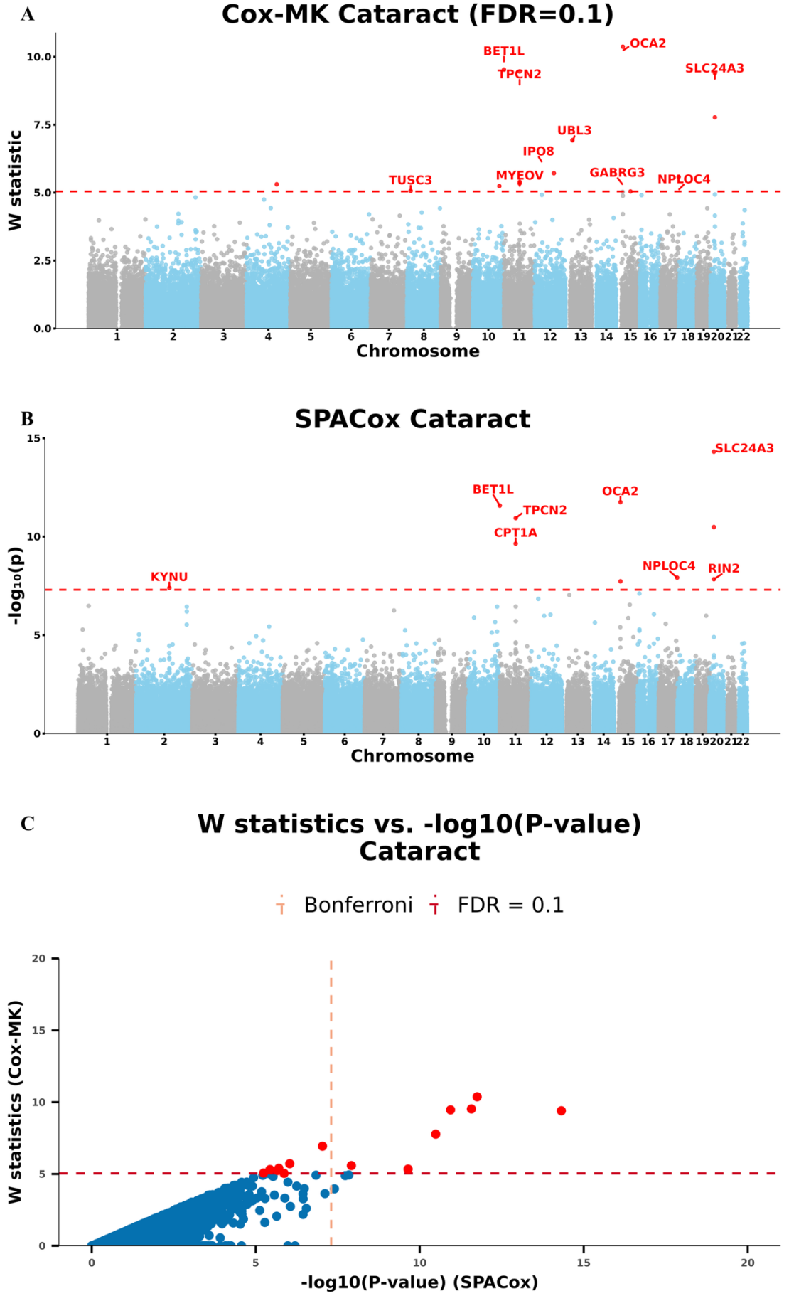
Figure S5. Manhattan plots for GWAS of cataract in the UK Biobank data with White British ancestry
(A and B) GWAS results using (A) Cox-MK and (B) SPACox are shown for cataract.
- Scatter plot of W knockoff statistics (Cox-MK) vs. −log10(p value) (SPACox) for cataract.
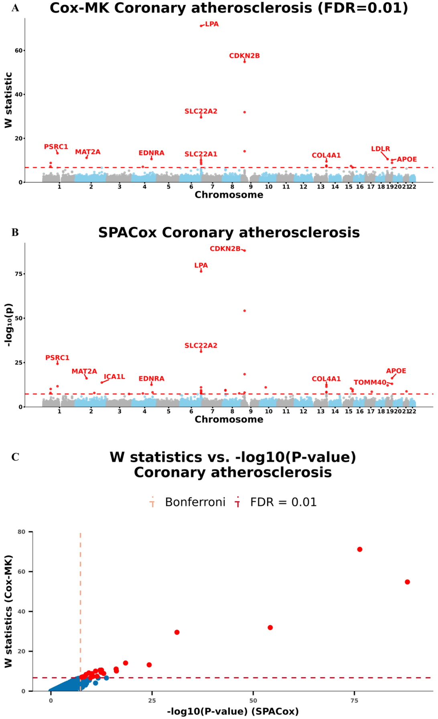
Figure S6. Manhattan plots for GWAS of coronary atherosclerosis in the UK Biobank data with White British ancestry
(A and B) GWAS results using (A) Cox-MK and (B) SPACox are shown for coronary atherosclerosis.
- Scatter plot of W knockoff statistics (Cox-MK) vs. −log10(p value) (SPACox) for coronary atherosclerosis.
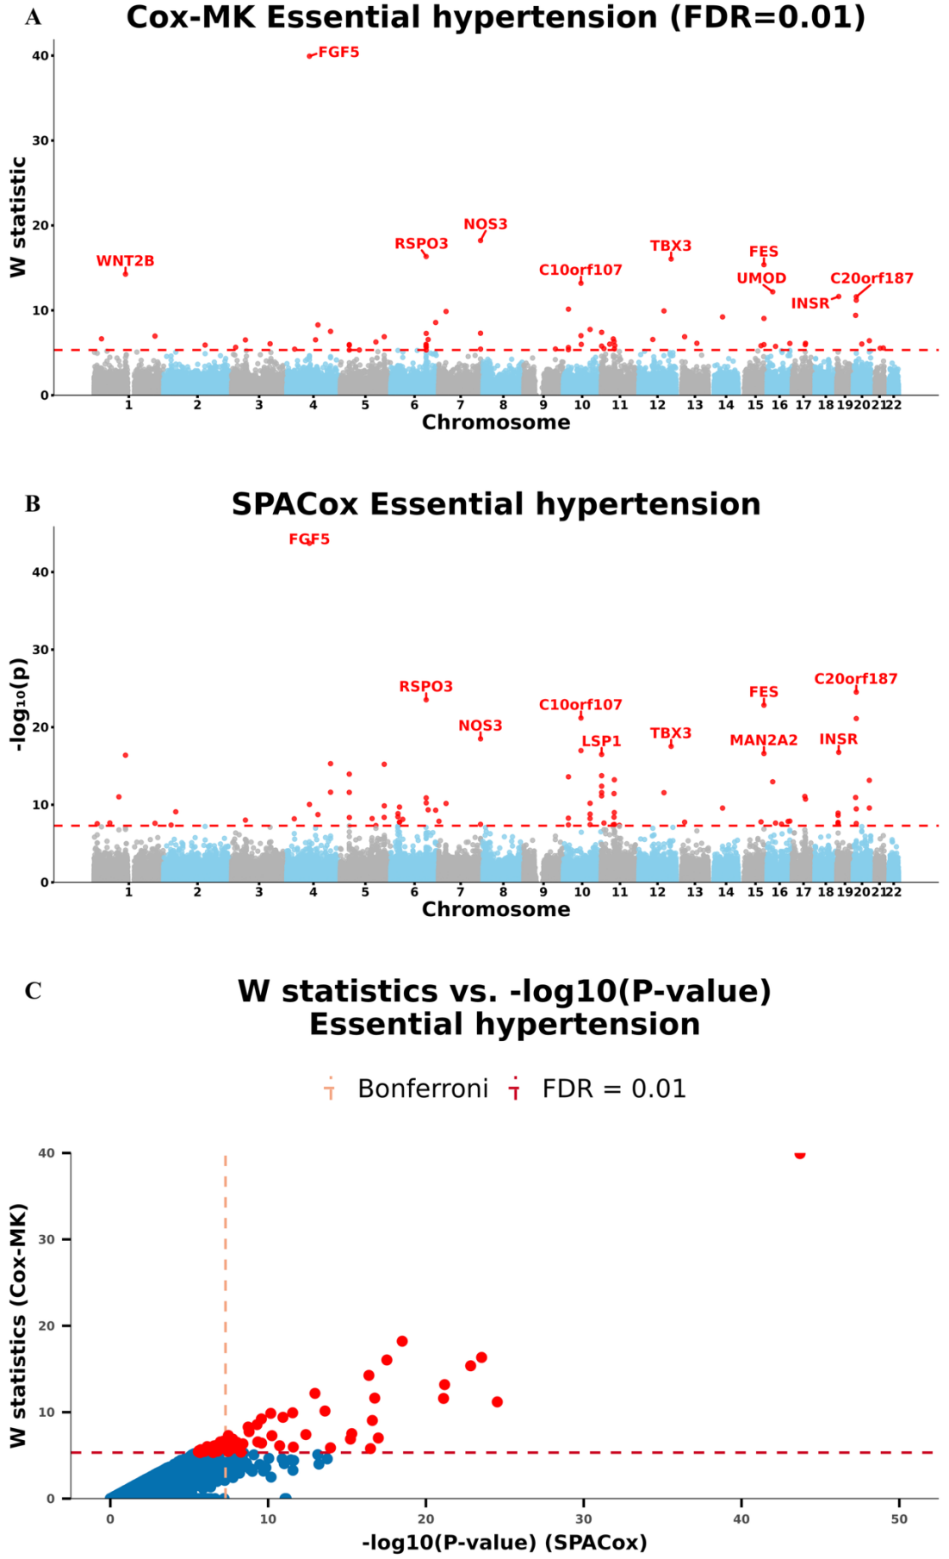
Figure S7. Manhattan plots for GWAS of essential hypertension in the UK Biobank data with White British ancestry
(A and B) GWAS results using (A) Cox-MK and (B) SPACox are shown for essential hypertension.
- Scatter plot of W knockoff statistics (Cox-MK) vs. −log10(p value) (SPACox) for essential hypertension.
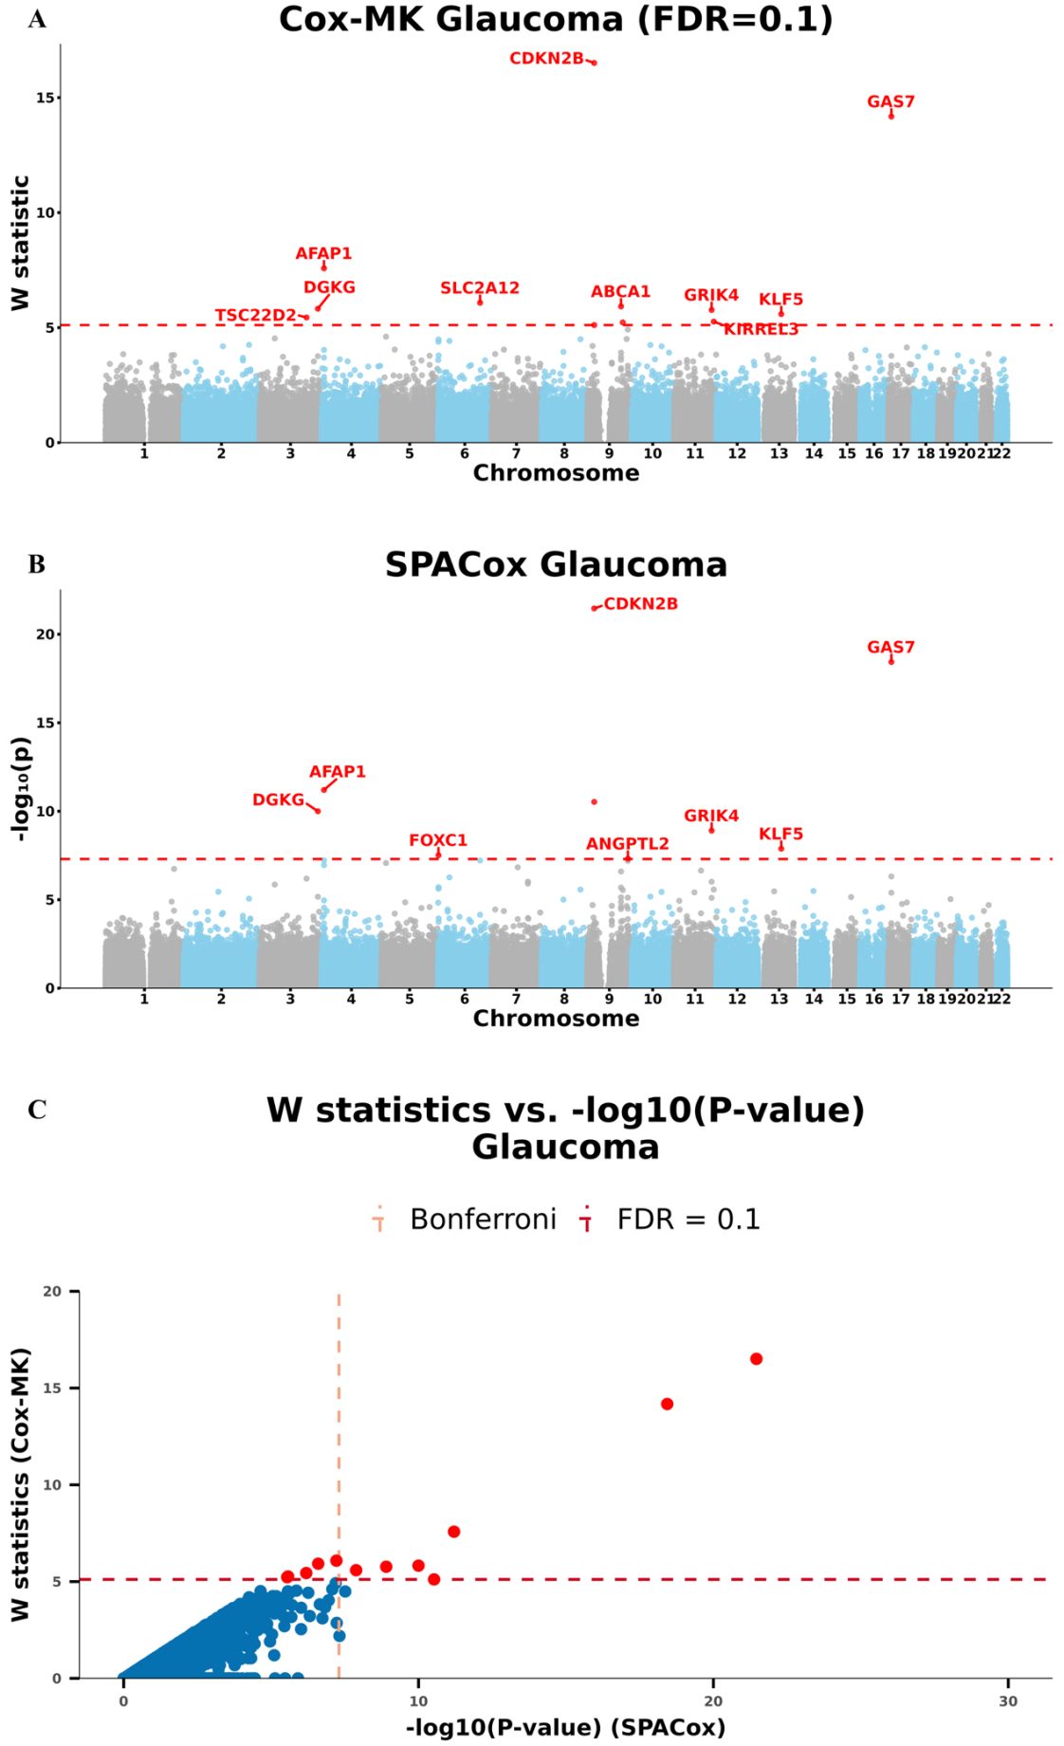
Figure S8. Manhattan plots for GWAS of glaucoma in the UK Biobank data with White British ancestry
(A and B) GWAS results using (A) Cox-MK and (B) SPACox are shown for glaucoma.
- Scatter plot of W knockoff statistics (Cox-MK) vs. −log10(p value) (SPACox) for glaucoma.
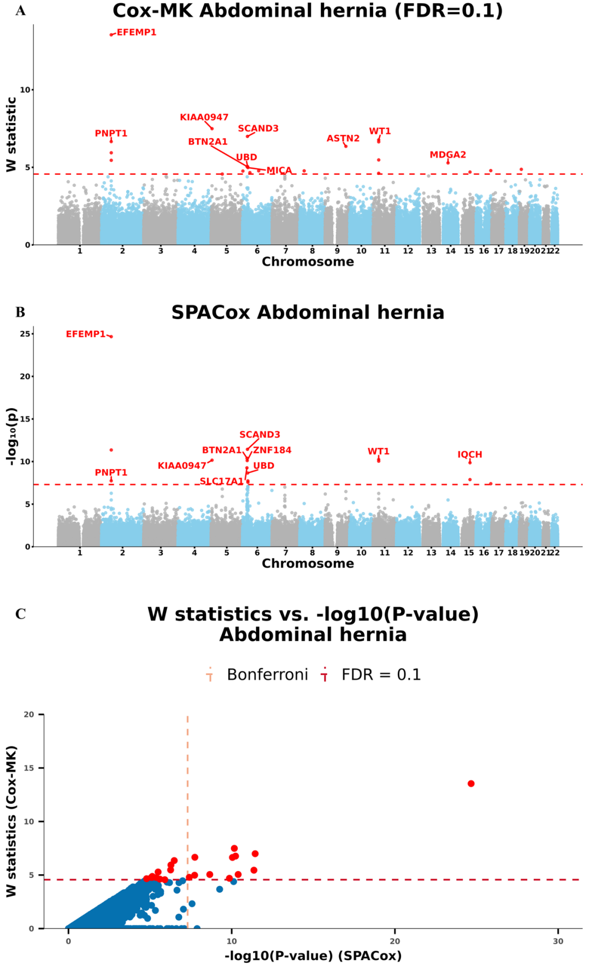
Figure S9. Manhattan plots for GWAS of abdominal hernia in the UK Biobank data with White British ancestry
(A and B) GWAS results using (A) Cox-MK and (B) SPACox are shown for abdominal hernia.
- Scatter plot of W knockoff statistics (Cox-MK) vs. −log10(p value) (SPACox) for abdominal hernia.
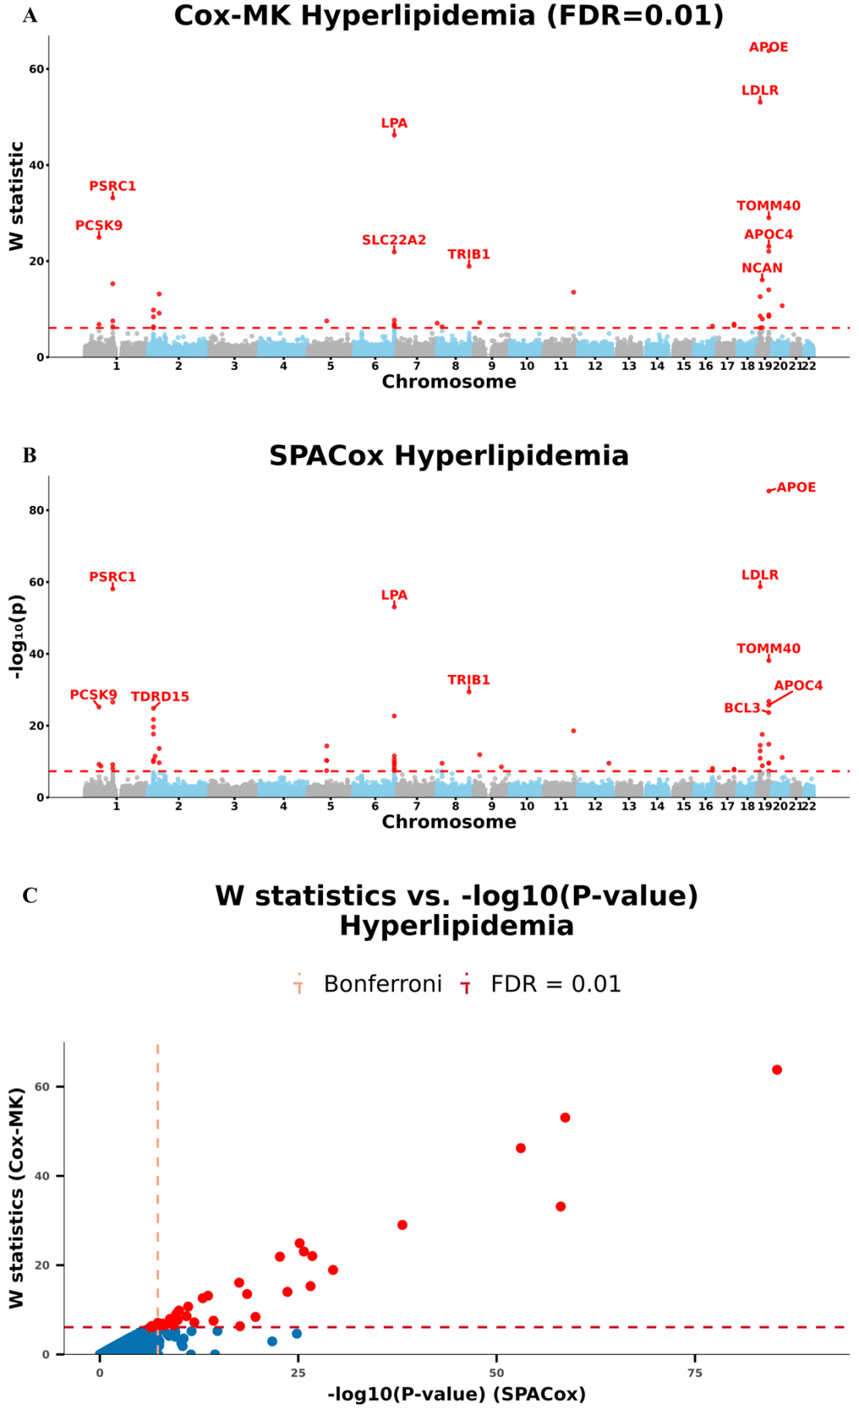
Figure S10. Manhattan plots for GWAS of hyperlipidemia in the UK Biobank data with White British ancestry
(A and B) GWAS results using (A) Cox-MK and (B) SPACox are shown for hyperlipidemia.
- Scatter plot of W knockoff statistics (Cox-MK) vs. −log10(p value) (SPACox) for hyperlipidemia.
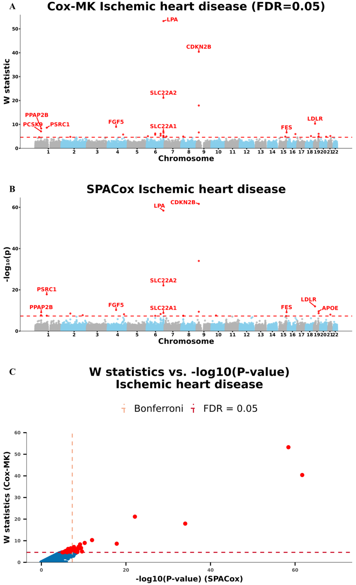
Figure S11. Manhattan plots for GWAS of ischemic heart disease in the UK Biobank data with White British ancestry
(A and B) GWAS results using (A) Cox-MK and (B) SPACox are shown for ischemic heart disease.
- Scatter plot of W knockoff statistics (Cox-MK) vs. −log10(p value) (SPACox) for ischemic heart disease.
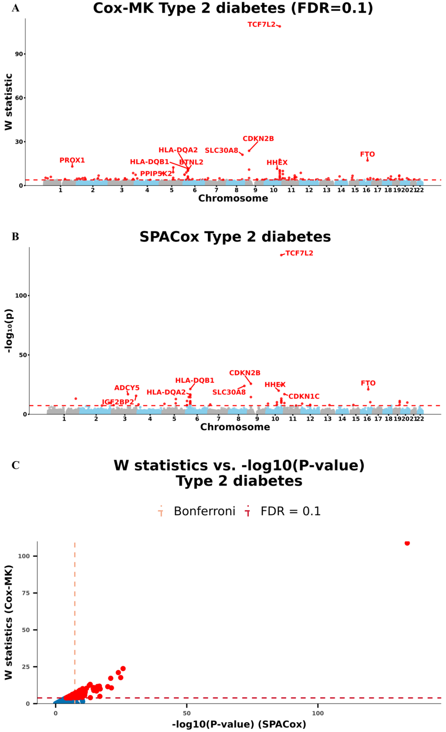
Figure S12. Manhattan plots for GWAS of T2D in the UK Biobank data with White British ancestry
(A and B) GWAS results using (A) Cox-MK and (B) SPACox are shown for T2D.
- Scatter plot of W knockoff statistics (Cox-MK) vs. −log10(p value) (SPACox) for T2D.

